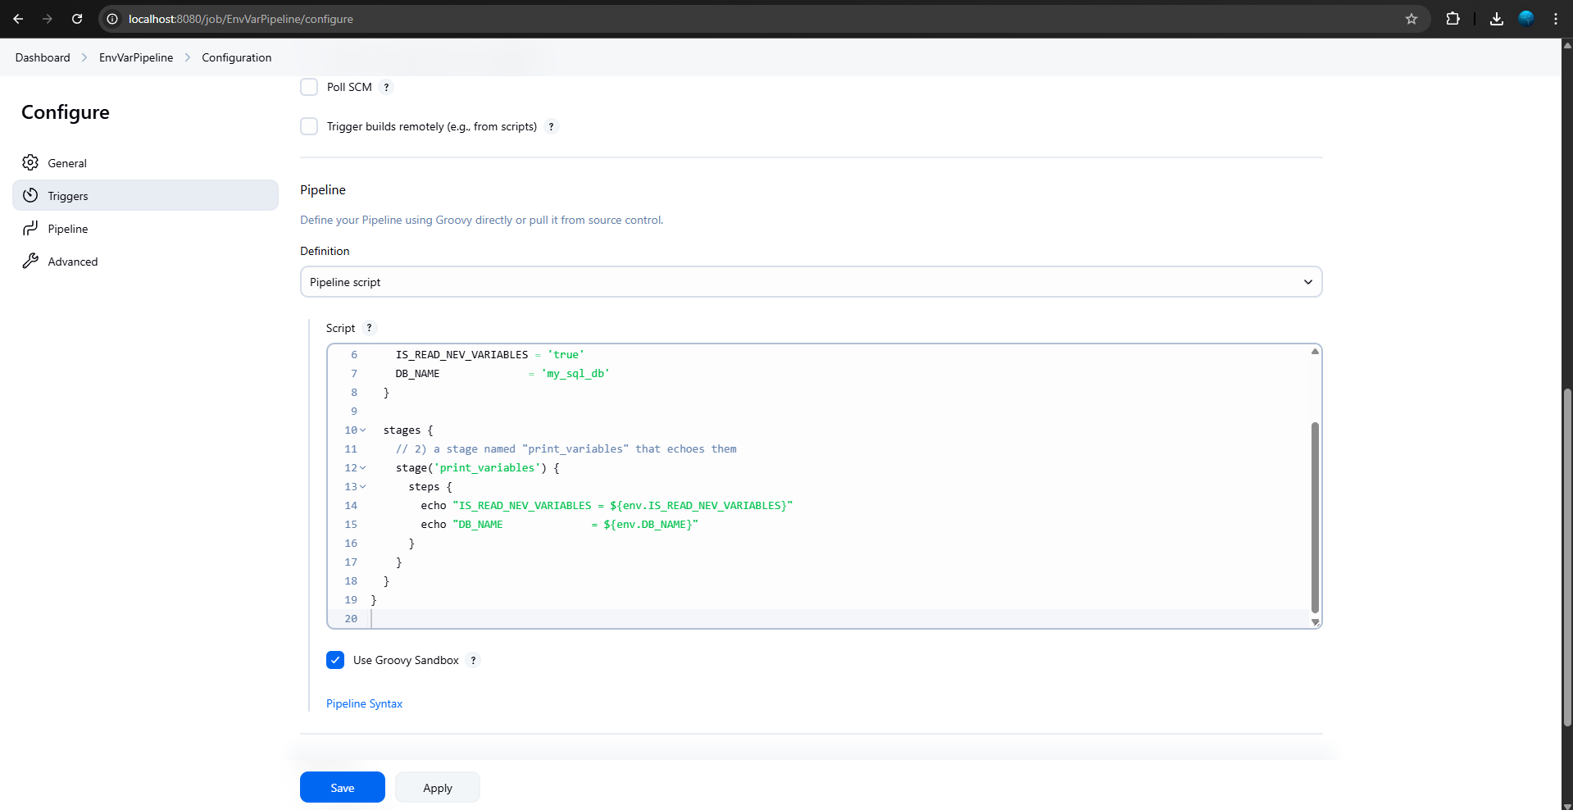

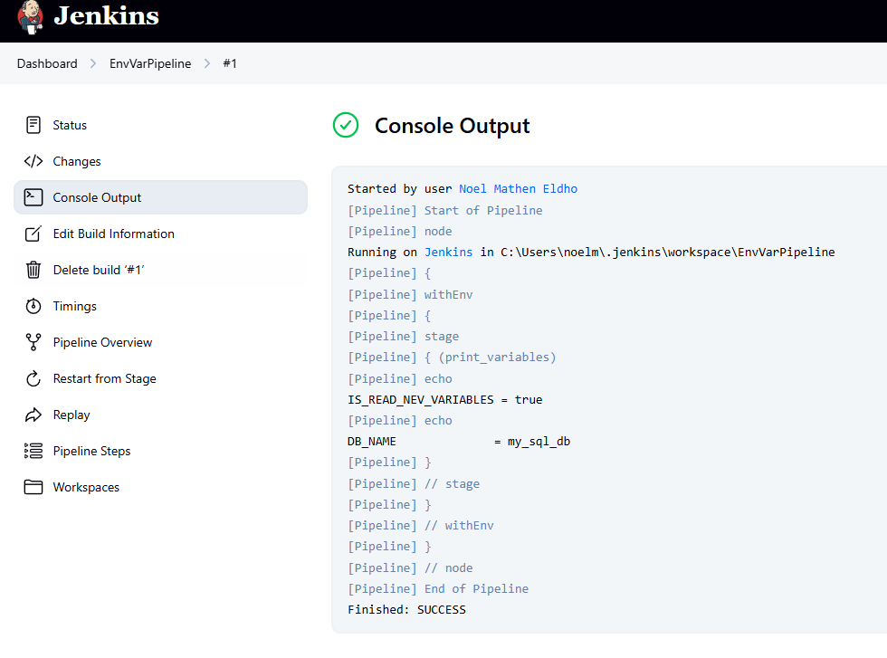

Pipeline Script:

pipeline {

agent any

// 1) declare the two environment variables

environment {

IS_READ_NEV_VARIABLES = 'true'

DB_NAME = 'my_sql_db'

}

stages {

// 2) a stage named "print_variables" that echoes them

stage('print_variables') {

steps {

echo "IS_READ_NEV_VARIABLES = ${env.IS_READ_NEV_VARIABLES}"

echo "DB_NAME = ${env.DB_NAME}"

}

}

}

}